Disorders of Calcium and Phosphate Metabolism

Physiology:

Calcium and phosphate metabolism is based on a balance between intestinal absorption, bone mineralization and demineralization, and urinary filtration and reabsorption. The major direct regulators of this balance (besides dietary intake) are parathyroid hormone (PTH) and 1,25 (OH)₂-cholecalciferol (aka calcitriol), with a minor contribution from calcitonin.

PTH is a peptide hormone secreted by the chief cells of the parathyroid glands. PTH levels change very rapidly with alterations in serum calcium, as the half-life of PTH is only 10 minutes.

Calcitriol is the active form of vitamin D₃, a hormone produced from cholesterol, through enzymatic steps in the liver and kidneys, and a non-enzymatic UV-dependent step in the skin (which can be bypassed by adequate dietary intake of cholecalciferol).

Calcitonin is a peptide hormone secreted by the C cells of the thyroid. Calcitonin levels are generally very low (sometimes non-detectable) in most people, only rising in the setting of severe hypercalcemia or medullary carcinoma of the thyroid.

An overview of the interaction between calcium, phosphate, PTH, calcitriol, and calcitonin:

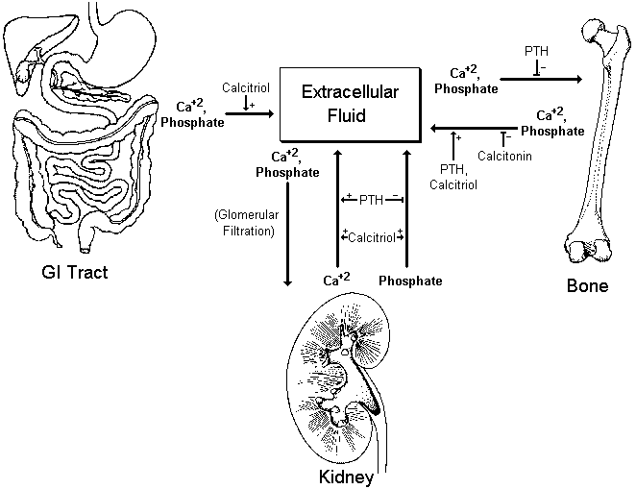

In general, changes in serum calcium affect PTH levels more, while changes in serum phosphate affect calcitriol levels more. Although both electrolytes are interrelated, an isolated derangement of one generally leads to only a mild derangement of the other.

Production of calcitriol: | 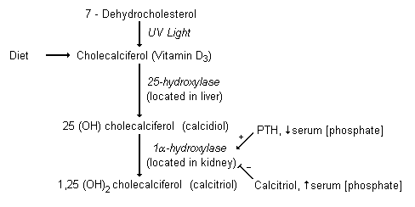

Regulation of PTH Secretion: |  | Effect of pH on Calcium/Phosphate Metabolism:
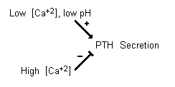 |  | Low pH  ↓  Increased secretion of PTH  ↓  Increased urinary excretion of phosphate  ↓  Increased net acid excretion by increased buffering of excreting H⁺ ions

At any one time, most of the calcium in the body exists as the mineral hydroxyapatite, Ca₁₀(PO₄)₆(OH)₂.

Calcium in the plasma: 45% in free, ionized form (the physiologically active form)
45% bound to proteins (predominantly albumin)
10% complexed with anions (citrate, sulfate, phosphate)

To estimate the physiologic levels of ionized calcium in states of hypoalbuminemia:

[Ca⁺²]_{Corrected} = [Ca⁺²]_{Measured} + [ 0.8 (4 – Albumin) ]

The binding of calcium to albumin is also pH dependent, increasing with alkalosis, and decreasing with acidosis.

Overview of the Differential Diagnosis of Calcium Disorders

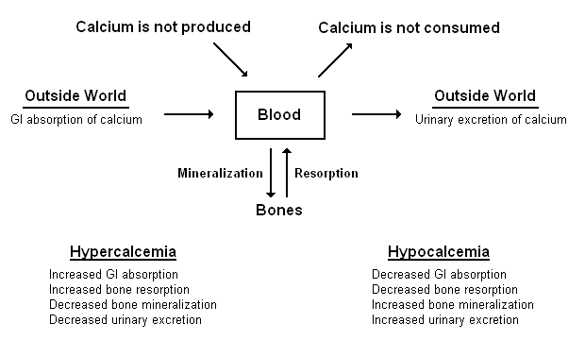

Hypercalcemia

Symptoms: Polyuria, dehydration, confusion, depression, fatigue, nausea/vomiting, anorexia, abdominal pain, and renal stones. (Aside from nephrolithiasis, most symptoms are not seen until serum [Ca⁺²] > 12mg/dL.)

Signs: Diminished reflexes, short QT interval on ECG.

Etiologies:

Increased GI Absorption of Calcium
Milk-alkali syndrome (The combination of hypercalcemia, alkalosis, and renal insufficiency seen in the setting of high intake of milk or CaCO₃. Predominantly occurs in renal failure, osteoporosis, or GERD)
Elevated Calcitriol
Vitamin D excess
Chronic granulomatous diseases – This is most common in sarcoidosis, but also is seen in TB & histoplasmosis. It occurs because calcitriol can be produced by activated macrophages within granulomas.
Excessive vitamin D intake
Acromegaly (although the combination of acromegaly and hypercalcemia should suggest MEN I)
Lymphoma
Elevated PTH (see below)
Hypophosphatemia (see section on hypophosphatemia)

Increased Calcium Loss From Bone
Increased Bone Resorption
Elevated PTH
Primary hyperparathyroidism
Adenoma (80% of 1° hyperparathyroidism)
Hyperplasia (15%)
Carcinoma (<5%)
Tertiary hyperparathyroidism – This occurs when an autonomous parathyroid nodule develops in the setting of long standing secondary hyperparathyroidism.
Chronic lithium therapy (probable mechanism)
Acidemia (from any cause)
Malignancy (Hypercalcemia in malignancy is a grave prognostic factor: Median survival = 1-6 months)
Osteolytic disease
PTHrP secreting tumor (most commonly squamous cell carcinoma of the lung)
Pheochromocytoma (although the combination of of pheochromocytoma & hypercalcemia should suggest MEN II)
Increased bone turnover
Immobilization
Hyperthyroidism
Hypervitaminosis A / retinoic acid
Paget’s disease of bone
Elevated calcitriol (see above)

Decreased Bone Mineralization
Aluminum intoxication – This is most commonly seen in end-stage renal disease.
Elevated PTH (see above)

Decreased Urinary Calcium Excretion
Thiazide diuretics
Familial hypocalciuric hypercalcemia
Elevated calcitriol (see above)

Pseudohypercalcemia (due to increased protein binding of calcium in hyperprotiein states)
Severe dehydration (due to concentration of albumin)
Multiple Myeloma

In ambulatory patients, 90% of cases will be due to hyperparathyroidism.
In hospitalized patients, 65% of cases will be due to malignancy.

Diagnosis: |  | Phosphate | PTH | Calcitriol | Urinary Calcium
 | Primary Hyperparathyroidism | ↓ | ↑↑ | Variable | ↓ / Normal
 | Malignancy | Variable | ↓ / Normal | ↓ | ↑
 | Vitamin D Excess | ↑ | ↓ / Normal | ↑↑ | ↑ / Normal
 | Granulomatous Disease | ↑ | ↓ / Normal | ↑ | ↑
 | Milk-Alkali Syndrome | ↑ / Normal | ↓ / Normal | Normal | Normal
 | Thiazide Diuretics | ↑ / Normal | ↓ / Normal | Normal | ↓

The combination of a thorough history and physical exam, CXR, calcium, albumin, phosphate, alkaline phosphatase, vitamin D level (or calcitriol), and SPEP will correctly identify the etiology of hypercalcemia 95% of the time. Adding the relatively expensive intact PTH assay to this increases the diagnostic yield to 99%. The presence of PTHrP can also be checked if its presence is suggested by the preceding tests.

Treatment:

Primary Treatment |  | Secondary Treatment
Normal Saline (4-6L/day)  Furosemide (IV q2 – q6 hrs; start only after fluid replete) |  | Bisphosphanates (most useful in hypercalcemia due to malignancy)  Calcitonin (develops tachyphylaxis)  Glucocorticoids

Long-term medical treatment is largely ineffective.

Indications for surgical parathyroidectomy: 1. Serum calcium > 11.5 mg/dL
2. Decreased creatinine clearance
3. Urine calcium > 400 mg/day
4. Decreased bone mass
5. Nephrolithiasis

Hypocalcemia

Symptoms: Irritability, muscle cramps, depression, psychosis, bronchospasm, and seizures.

Signs: Increased reflexes, prolonged QT interval on ECG (the only cause of a prolonged QT with a normal duration of the T wave itself)

Chvostek’s sign – Tapping of the facial nerve induces contractions of the facial muscles
Trousseau’s sign – Inflation of a blood pressure cuff induces carpal spasm

Etiologies:

Decreased GI Absorption of Calcium
Poor dietary intake of calcium
Decreased GI absorption with normal dietary intake
Decreased calcitriol
Vitamin D deficiency
Poor dietary intake of vitamin D
Inadequate sunlight exposure
Malabsorption syndromes
Drugs – Any drug which increased activity of the P-450 system, increases inactivation of vitamin D. These include isoniazid, theophylline, rifampin, and most anticonvulsants.
Nephrotic syndrome – Due to loss of vitamin D binding protein in the urine
Decreased conversion of vitamin D to calcitriol
Liver failure – The conversion of vitamin D to calcidiol occurs in the liver
Renal failure - In chronic renal failure there is impaired production of calcitriol from calcidiol, predisposing the patient to osteomalacia, osteitis fibrosa cystica, and osteoporosis. The hyperphosphatemia often seen in renal failure also blocks conversion to calcitriol. This condition is often referred to as secondary hyperparathyroidism.
Low PTH (see below)
Hyperphosphatemia – This is due to the direct inhibition of 1α hydroxylase, which leads to decreased conversion of calcidiol to calcitriol.
Vitamin D dependent rickets, type 1 (aka psuedovitamin D deficient rickets) – An autosomal recessive disorder caused by a deficiency of 1α hydroxylase.
Vitamin D resistance
Hereditary vitamin D resistant rickets (formerly called vitamin D dependent rickets, type 2) – A disorder which manifests as end-organ resistance to calcitriol, most commonly due to mutations in the calcitriol receptor.

Increased Bone Mineralization
Low PTH (see below)
PTH resistance (see below)
Hungry bones syndrome – The rapid mineralization of bones following parathyroidectomy
Osteoblastic metastases – Occurs predominantly in patients with metastatic prostate or breast cancer.

Decreased Bone Resorption
Low PTH (see below)
PTH resistance (see below)
Decreased calcitriol (see above)

Increased Urinary Excretion of Calcium
Low PTH (aka hypoparathyroidism)
s/p thyroidectomy (most common cause of hypoparathyroidism)
Post I¹³¹ therapy for Graves disease or thyroid cancer
Autoimmune hypoparathyroidism
Isolated
Polyglandular Autoimmune Failure, type I – This is the combination of hypoparathyroidism, Addison’s disease, and chronic mucocutaneous candidiasis.
Hereditary hypothyroidism
Infiltration of the parathyroid
Hemochromatosis
Wilson’s disease
Metastatic cancer
Congenital hypoparathyroidism
Autosomal dominant hypocalcemia – The most common form of congenital hypoparathyroidism, characterized by mild to moderate hypocalcemia, relatively high urinary calcium excretion, and relatively low serum PTH concentrations. The disorder is caused by various activating mutations in the calcium-receptor gene.
DiGeorge Syndrome – This condition is associated with defective development of the third and fourth pharyngeal pouches, resulting in an absent/hypoplastic thymus, cardiac defects, and parathyroid hypoplasia. DiGeorge syndrome is usually due to a deletion on chromosome 22.
Hypomagnesemia – This is seen primarily in alcoholism, malabsorption syndromes, diarrhea, and aminoglycoside use.
PTH Resistance (aka pseudohypoparathyroidism) – A heterogeneous group of disorders characterized by end-organ resistance to PTH, classified as types 1a, 1b, 1c, 2, and pseudopseudohypoparathyroidism.
Deficiency of calcitriol (see above)

Internal Redistribution
Pancreatitis (due to formation of calcium salts in retroperitoneal fat)

Intravascular Binding
Citrate excess from multiple transfusions – Citrate chelate calcium in the serum, dropping levels of the active ionized form, without affecting total calcium levels.
Acute respiratory alkalosis – Elevated pH causes more calcium to become bound to albumin, also dropping levels of ionized calcium.

Diagnosis: |  | Phosphate | PTH | Calcitriol
 | Hypoparathyroidism | ⁭ | ↓ | ↓
 | Psuedohypoparathyroidism | ⁭ | ↑↑ | ↓
 | Chronic renal failure | ⁭ | ↑ | ↓
 | Vitamin D deficiency | ↓ | ↑ | ↓

Treatment: Asymptomatic – Oral calcium and vitamin D supplementation
(Must give calcitriol in renal failure)

Symptomatic – IV calcium gluconate
(200mg IV over 10min, then 50-150mg/hr for a total of 15mg/kg)

Overview of the Differential Diagnosis of Phosphate Disorders

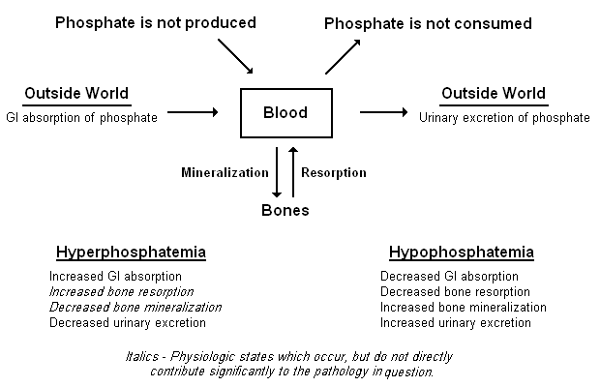

Hyperphosphatemia

Symptoms: When they occur, they are actually usually related to concurrent hypocalcemia.

Etiologies:

Increased GI intake – This is usually due to the laxative, Fleet’s Phospho-Soda, and almost always in conjunction with some degree of renal insufficiency.

Decreased urinary renal excretion
Renal Failure (occurs when GFR < 20-25 mL/min)
Increased active renal reabsorption of phosphate
Hypoparathyroidism (see under hypocalcemia)
Acromegaly – The hyperphosphatemia seen in this setting is of no clinical consequence.
Bisphosphonates
Hyperthyroidism – The hyperphosphatemia seen in this setting is of no clinical consequence
Dehydration
Familial tumoral calcinosis - A rare autosomal recessive disorder characterized by hyperphosphatemia, calcified soft-tissue masses, and normal [Ca⁺²].

Internal Redistribution
Cell lysis
Tumor lysis syndrome
Rhabdomyolysis
Transmembrane shift
Metabolic acidosis – This results from decreased glycolysis and decreased intracellular phosphate utilization.

Pseudohyperphosphatemia
Multiple Myeloma

Treatment: Acute – Will usually resolve spontaneously in 6-12 hours. If levels are life-threatening, saline infusion and acetazolamide can increase phosphate excretion in the setting of normal renal function.
Chronic – Only occurs in chronic renal failure and familial tumor calcinosis. It is best treated by a low phosphate diet, phosphate binders such as calcium acetate (PhosLo), and dialysis.

Hypophosphatemia

Symptoms: Mild symptoms are not seen until serum phosphate < 2.0 mg/dL. Serious symptoms do not occur until serum phosphate < 1.0 mg/dL. Symptoms are generally due to one of three mechanisms:

- Hypophospatemia induces bone resorption. When prolonged, this leads to osteomalacia and rickets.
- Intracellular ATP levels fall, leading to impairment of muscle contractility (manifesting as proximal muscle weakness, dysphagia, ileus, respiratory failure, and acute CHF), metabolic encephalopathy (irritability, paresthesias, confusion, coma), increased RBC rigidity (predisposing to hemolysis), impaired phagocytosis, and impaired granulocyte chemotaxis.
- Red cell 2,3 DPG levels fall, increasing the affinity of hemoglobin for oxygen, and leading to reduced oxygen release and tissue ischemia.

Clinically significant rhabdomyolysis can also be seen when acute hypophospatemia occurs in the setting of severe chronic phosphate depletion. This occurs almost exclusively in alcoholics.

Etiologies:

Decreased GI Intake
Decreased dietary intake of phosphate – This is rare unless accompanied by another etiology, such as diarrhea, malabsorption, or vitamin D deficiency, due to ability of the proximal tubules to adapt in order to reabsorb nearly 100% of the filtered phosphate load.
Decreased GI absorption with normal dietary intake
Malabsorption
Diarrhea
Phosphate binders (e.g. calcium acetate, and aluminum and magnesium containing antacids)

Increased Bone Mineralization / Decreased Bone Resorption
Hungry bones syndrome

Increased Urinary Excretion
Primary or tertiary hyperparathyroidism
Vitamin D deficiency/resistance
Fanconi syndrome – This is a generalized impairment in proximal tubular function, leading to hypophosphatemia, renal glucosuria, hypouricemia, aminoaciduria, and type 2 RTA.
Multiple Myeloma (by far the most common cause of Fanconi syndrome in adults)
Cystinosis
Wilson’s disease
Hereditary fructose intolerance

Internal Redistribution – Stimulation of glycolysis can increase intracellular phosphate utilization, and decrease serum phosphate levels, particularly in patients with starting out with borderline phosphate depletion.
Refeeding syndrome (most common in patients with alcoholism or anorexia)
During treatment of DKA or hyperosmotic non-ketotic coma
Acute respiratory alkalosis (due to the positive effect of high intracellular pH on phosphofructokinase activity)

The conditions in which symptoms from hypophosphatemia are primarily seen are alcoholism (from poor intake combined with vitamin D deficiency) and the chronic ingestion of antacids.

Diagnosis: Increased urine phosphate (>5-10mg/dL, >100mg/day, FEPO₄ > 5%) → Renal loses
Decreased urine phosphate (<5-10mg/dL, <100mg/day, FEPO₄ < 5%) → GI loses, poor intake

FEPO₄ = fractional excretion of phosphate = urine [PO₄] x plasma [Cr] x 100
urine [Cr] x plasma [PO₄]

Treatment: Asymptomatic – Treatment should be aimed at correcting the underlying abnormality and
phosphate supplementation is generally not needed.

Symptomatic (or in the setting of a renal tubular defect) – In addition to addressing the underlying cause, phosphate should be repleted. The PO route is preferred over IV, as IV phosphate can precipitate with calcium, potentially leading to hypocalcemia, renal failure, and fatal arrhythmias.

Repletion via PO (neutra-phos, Fleet’s phospho-soda): 2.5-3.5g/day in divided doses.

Repletion via IV (sodium phosphate, potassium phosphate): ≤ 2.5mg/kg per 6 hours.

Some evidence exists that dipyridamole may increase renal phosphate reabsorption, but further studies are needed to evaluate its clinical efficacy and safety.

